Progressive Web Apps – HTML , css and JS is all you need

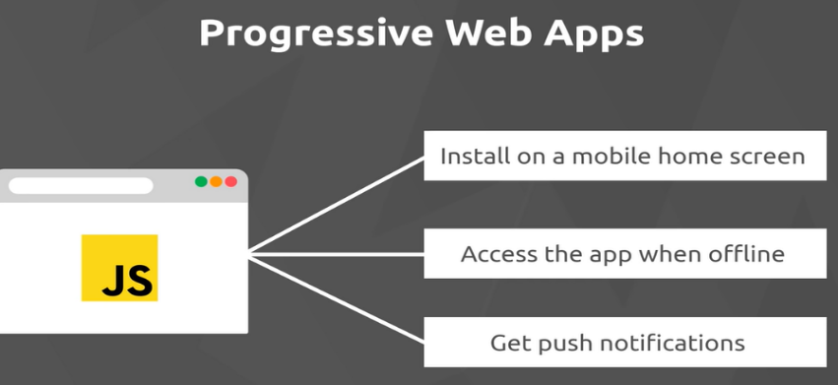

Native apps

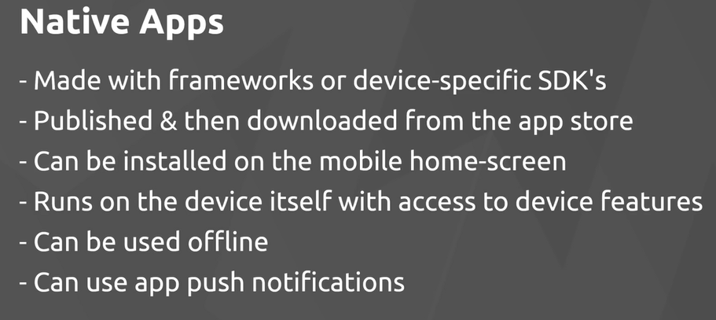

Service workers can be used to run off line

PWA’s are new and there are a lot of changes, not all browsers support

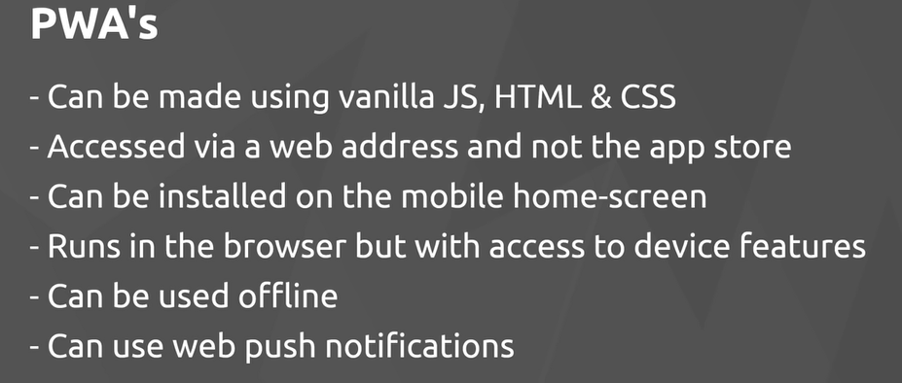

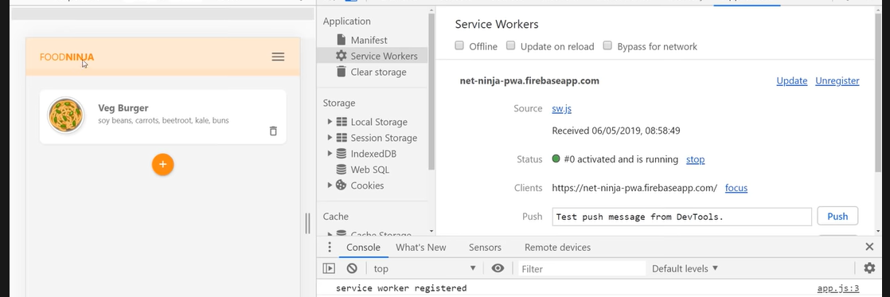

Video 2 <https://www.youtube.com/watch?v=JQaL5YiSuqE>

Using Materialize CSS for the app

Downloaded the min.css from materialize and min.js

Server page in HTML protocol – live server in VS code

Using Materialize to stye the page

#1- make it mobile device responsive

Video 3- The Web app Manifest file - info about how to display app – safari only partially supports

<https://www.youtube.com/watch?v=AlEdGOLhuM8>

Need to create a web app manifest file. A single JSON file which is going to supply info about app to the browser – name , home screen icon, color theme ect . So browser knows how to display the app on a mobile device.

<https://developer.mozilla.org/en-US/docs/Web/Manifest>

<https://web.dev/add-manifest/>

Must be called manifest.json and be in the root of the project –

Define the name that will be displayed on splash screen

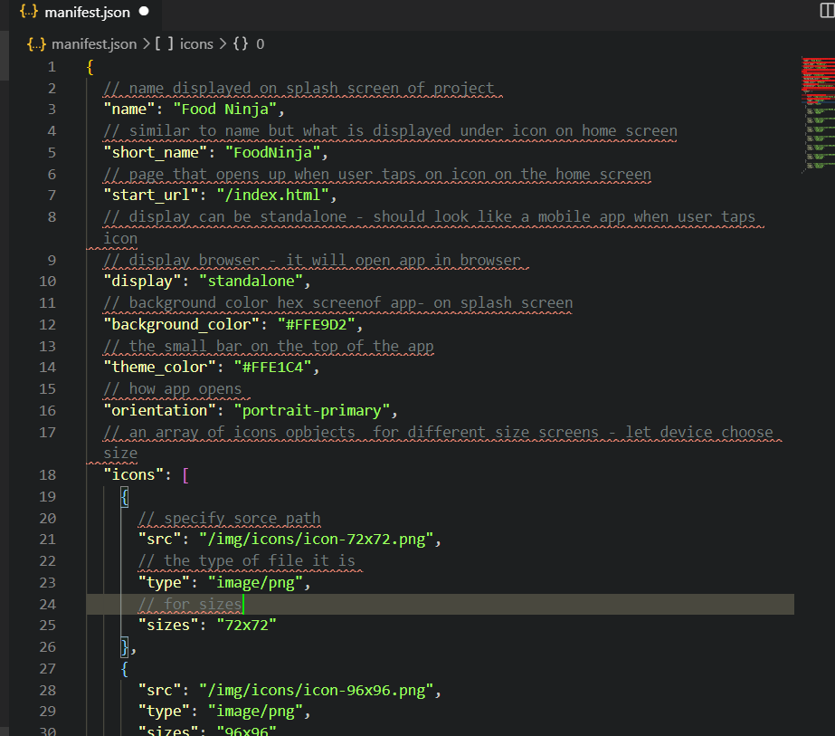

After creating the file create link to in in each HTML file.

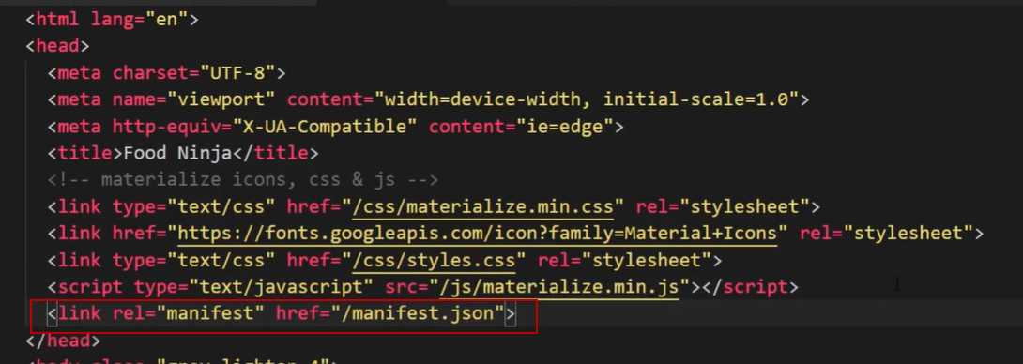

You can see this in dev tools under Application > Manifest

